**Milestone 3: Forecasting Model Performance Report**

**Introduction**

This milestone focuses on building and evaluating multiple forecasting models to predict future sales using historical data. The dataset represents a retail sales time series with clear seasonal patterns. Models were trained and compared using consistent metrics to select the most accurate and stable forecasting approach.

**Methodology**

The data was cleaned and divided into training and testing sets by date. Five models were developed: Prophet, SARIMAX, XGBoost, ARIMA, and LightGBM. Each model was tuned and evaluated using two key accuracy measures: Mean Absolute Error (MAE %) and Root Mean Squared Error (RMSE %). These metrics provide a direct measure of prediction accuracy and model reliability.

**Results and Evaluation**

Model performance showed clear differences in both error magnitude and stability.

Prophet achieved the lowest MAE = 10.51 % and RMSE = 15.77 %, indicating strong consistency and smooth residual patterns across time. SARIMAX followed with MAE = 10.91 % and RMSE = 19.96 %, effectively capturing seasonal behavior but with slightly higher variance in residuals. ARIMA recorded MAE = 13.00 % and RMSE = 17.00 %, providing a moderate baseline but less effective trend adaptation. XGBoost had MAE = 12.83 % and a much higher RMSE = 48.34 %, indicating overfitting and poor generalization. LightGBM continued to underperform relative to the others, reaffirming that traditional time-series methods are better suited for this dataset’s structure and seasonality.

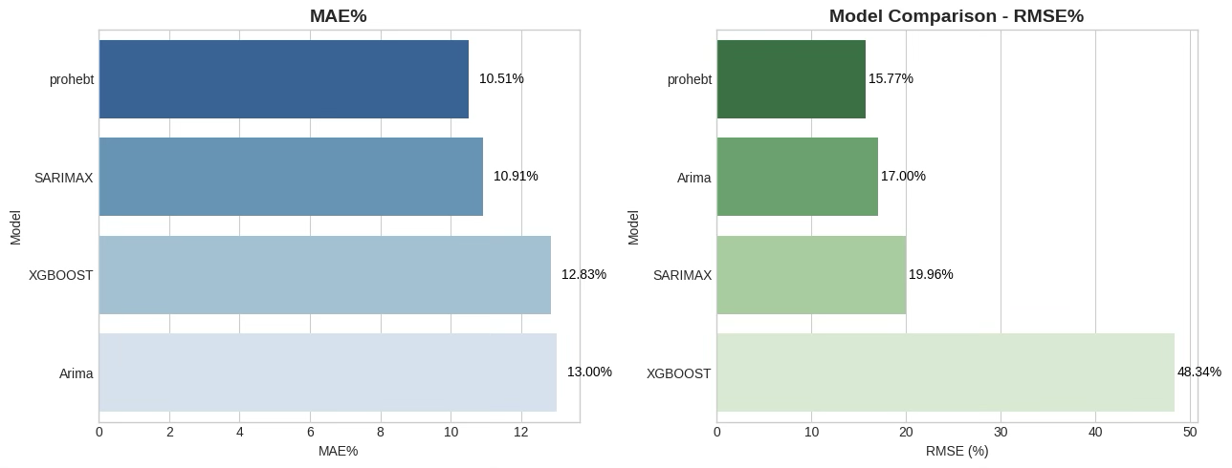

Therefore, Prophet’s error pattern was smooth and consistent, while the other models showed more variation.

**Final Model Selection**

Prophet was selected as the final model due to its lowest error values (MAE 10.51 %, RMSE 15.77 %) and balanced performance across all time periods. It accurately captured the overall trend, recurring seasonal effects, and holiday patterns without signs of overfitting, making it the most reliable and production-ready forecasting model.

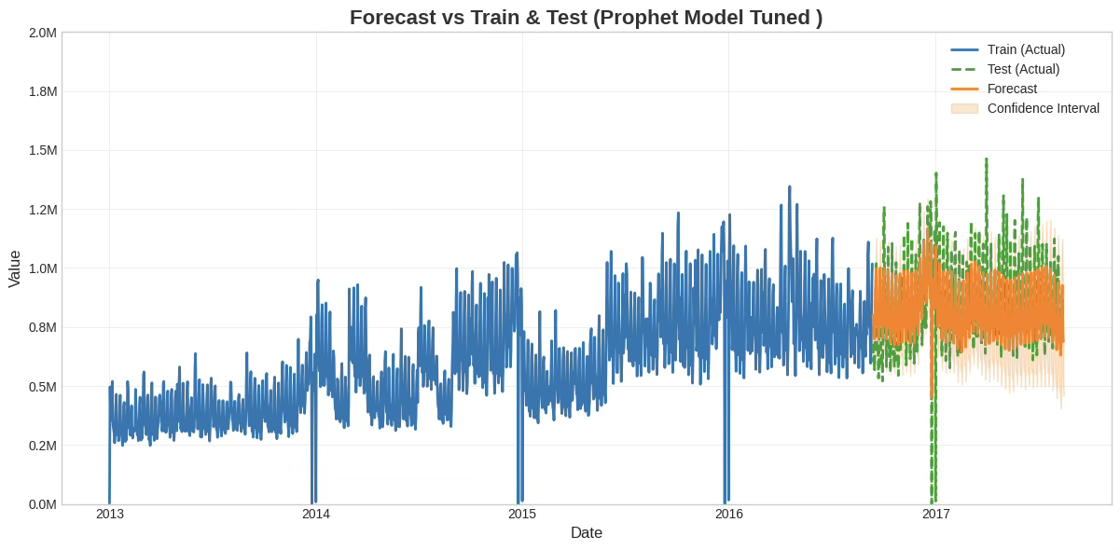

**Conclusion**

Prophet demonstrated superior forecasting accuracy and generalization compared with SARIMAX, ARIMA, XGBoost, and LightGBM. Its strong performance on both MAE and RMSE confirms its suitability for deployment in the next milestone. Implementing Prophet will enable more accurate sales planning and inventory management, enhancing data-driven decision-making across business operations.